CE301 Individual Capstone Project dp19963

**Goals until the next meeting:**

Until my fifth meeting with my supervisor I did the following, started on the world map game and just setup how the minigame is going to look.

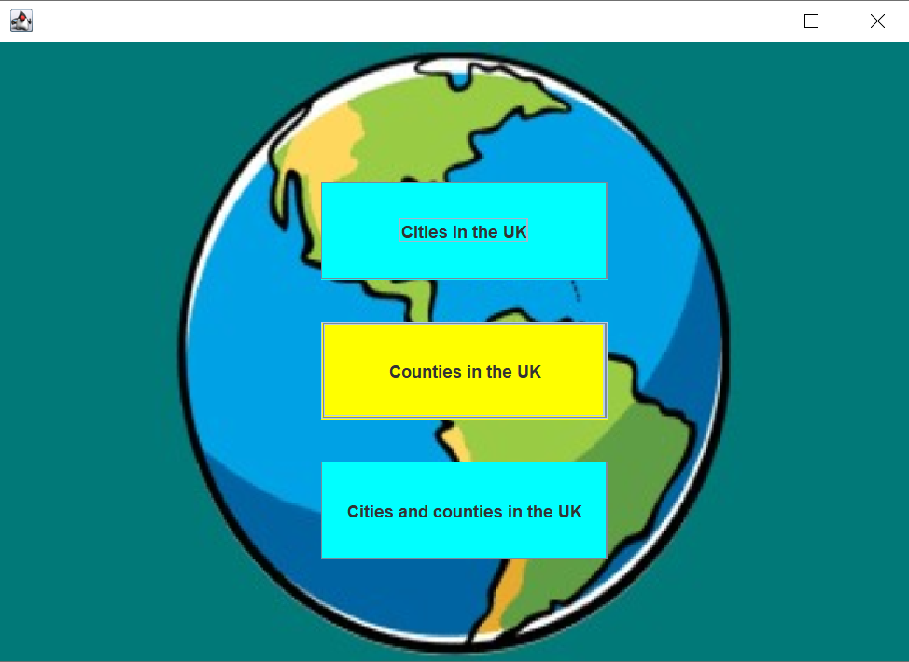

So you have the option to decide on what you want to focus on, between cities, counties or cities and counties in the UK.

So if you want to play with just counties then it’s going to look a bit like this. There’s no functionality added to this version yet but there will be a timer and a random county appearing probably to the left side of the frame telling you which county and how much time (probably 10 seconds per county).